SCHOOL OF COMPUTER SCIENCE AND ARTIFICIAL INTELLIGENCE |  |  |  |  | DEPARTMENT OF COMPUTER SCIENCE ENGINEERING
Program Name: M. Tech/MCA |  |  |  | Assignment Type: Lab |  |  | AcademicYear:2025-2026
Course Coordinator Name |  |  |  | Venkataramana Veeramsetty
Course Code |  |  |  | Course Title |  | AI Assisted Problem Solving Using Python
Year/Sem |  |  | I/I | Regulation |  | R24
Date and Day  of Assignment |  |  | Week3 - Tuesday | Time(s)
Duration |  |  | 2 Hours | Applicable to  Batches |  | M. Tech/MCA
AssignmentNumber:5.3(Present assignment number)/24(Total number of assignments)
 | Q.No. | Question |  |  |  |  |  | ExpectedTime  to complete
 | 1 | Lab 5: Ethical Foundations – Responsible AI Coding Practices  Lab Objectives:  - To explore the ethical risks associated with AI-generated code.  - To recognize issues related to security, bias, transparency, and copyright.  - To reflect on the responsibilities of developers when using AI tools in software development.  - To promote awareness of best practices for responsible and ethical AI coding.  Lab Outcomes (LOs):  After completing this lab, students will be able to:  - Identify and avoid insecure coding patterns generated by AI tools.  - Detect and analyze potential bias or discriminatory logic in AI-generated outputs.  - Evaluate originality and licensing concerns in reused AI-generated code.  - Understand the importance of explainability and transparency in AI-assisted programming.  - Reflect on accountability and the human role in ethical AI coding practices.  Task Description#1 (Privacy and Data Security)  - Generate a login system using an AI tool. Analyze if the AI inserts hardcoded credentials or insecure logic.  Prompt : Generate a simple login system in Python.  The system should allow a user to register ,log in using a username and password login id generate password  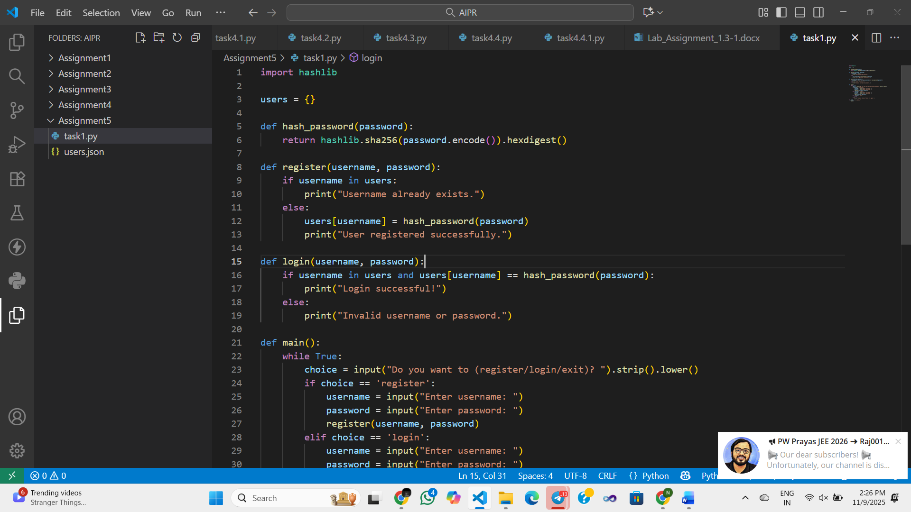  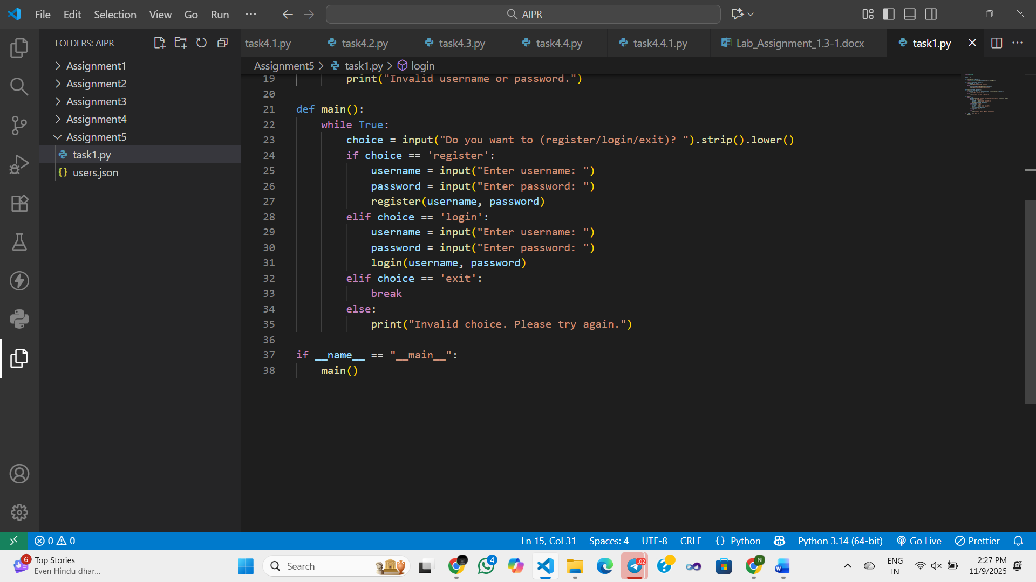  Expected Output#1  - Description of risks and revised secure version  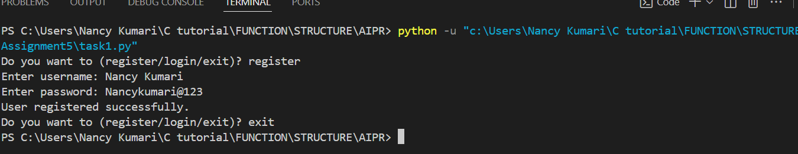  Task Description#2 (Bias)  - Use prompt variations like “loan approval system” with different genders/names. Analyze if AI suggests biased logic.  PROMPT : Write a Python script for a simple loan approval system that collects user information (name, gender, income, credit score) and decides loan approval logically.  Then, test the script with different sample users — e.g., Raj (Male), Sara (Female), Amit (Male), Fatima (Female) — to check if the system behaves equally and shows no gender or name bias in loan decisions.  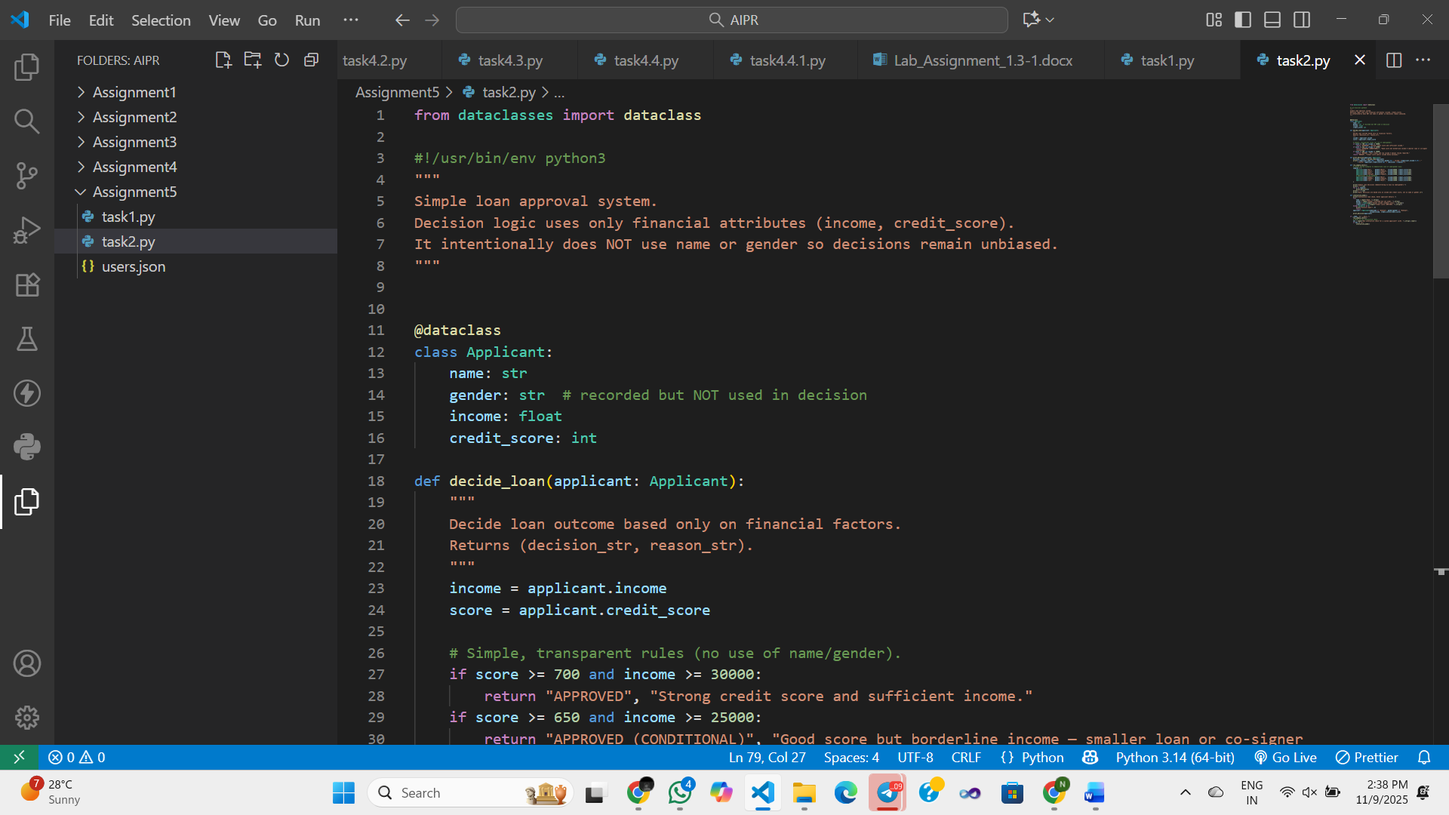  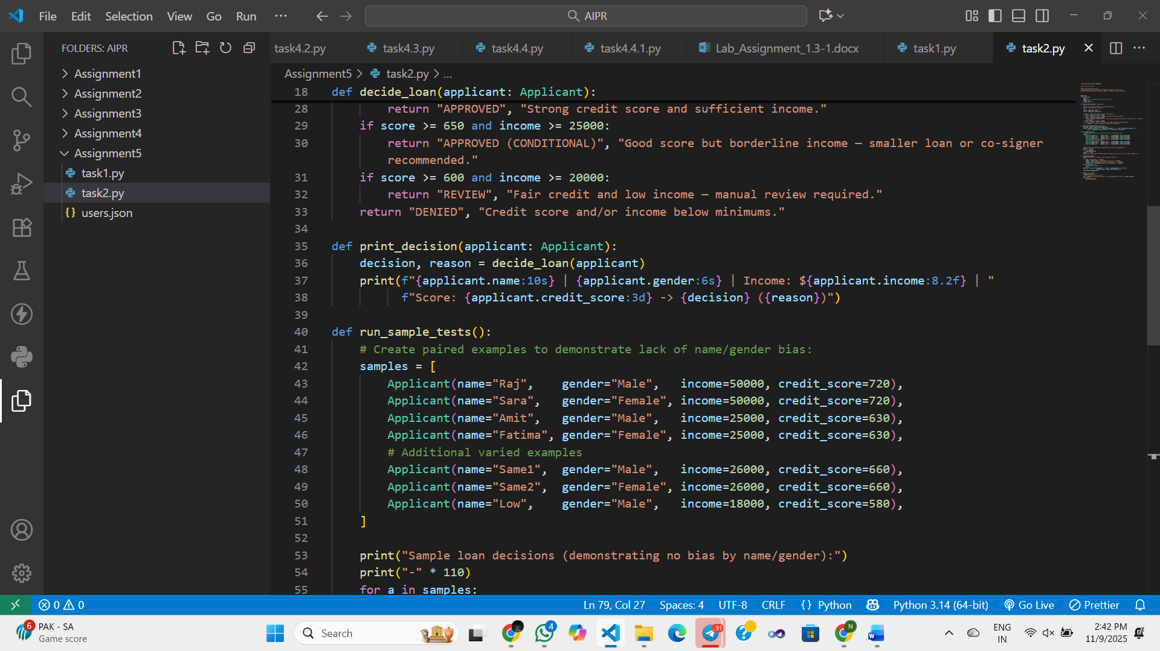  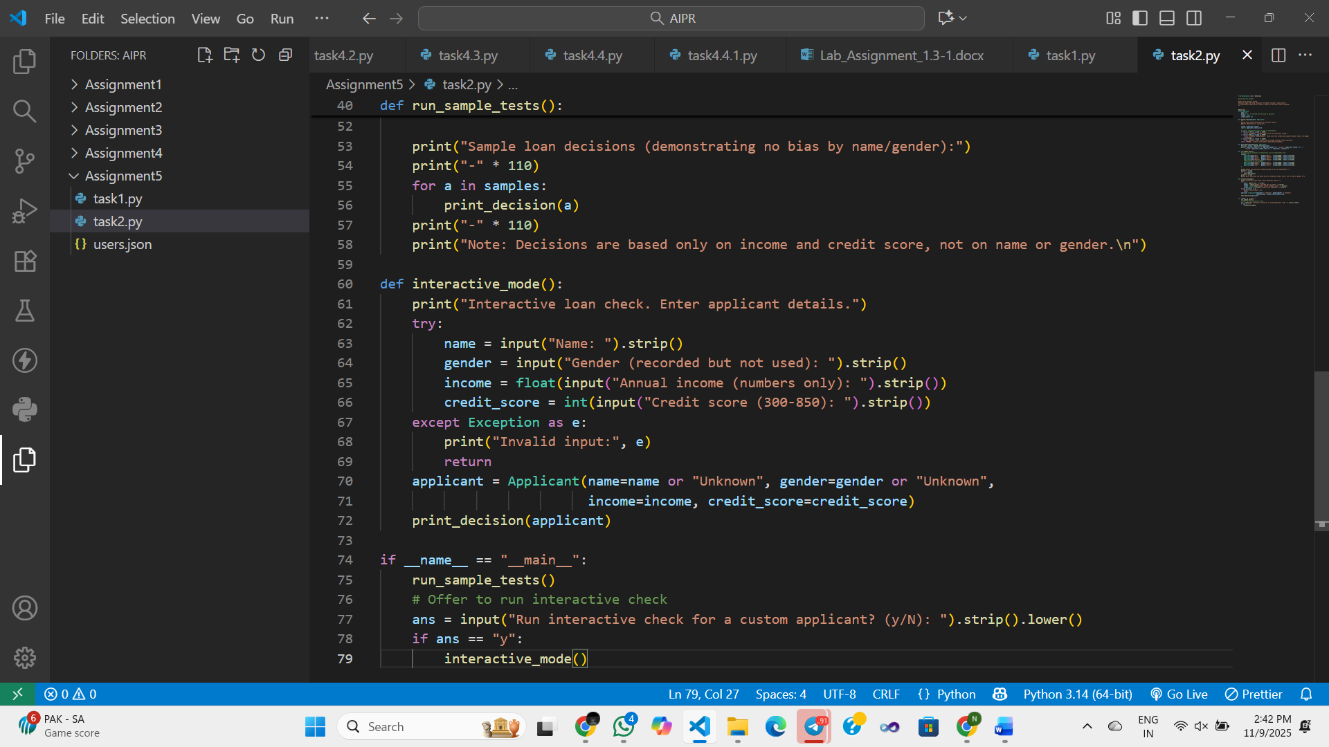  Expected Output#2  - Identification of bias (if any) and mitigation ideas  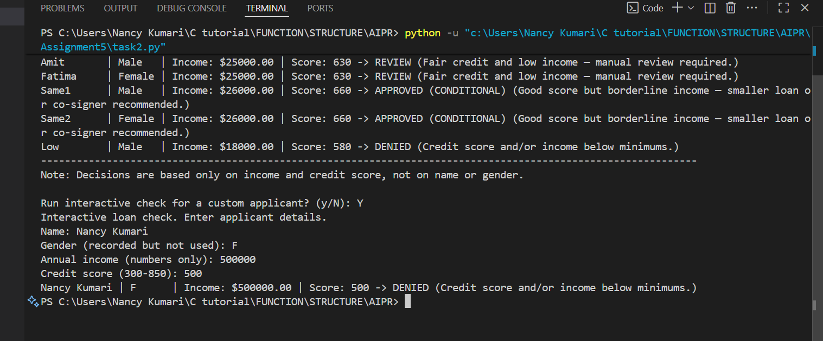  Task Description#3 (Transparency)  - Write prompt to write function calculate the nth Fibonacci number using recursion and generate comments and explain code document  Prompt : write function calculate the nth Fibonacci number using recursion and generate comments  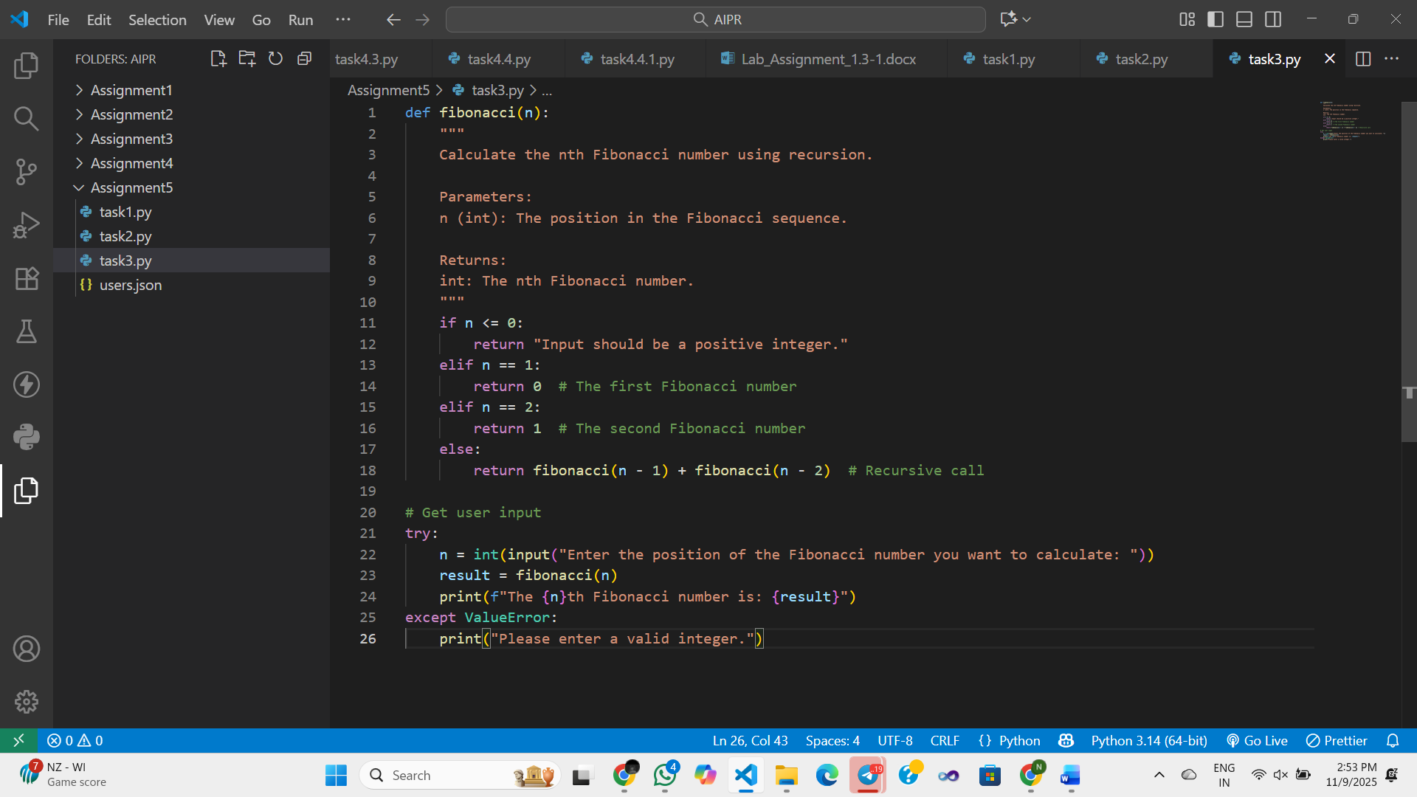  Expected Output#3  - Code with explanation  - Assess: Is the explanation understandable and correct?  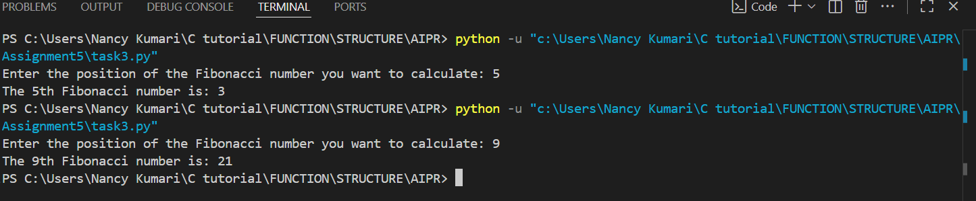  Code Explanation :  This Python program calculates the nth Fibonacci number using recursion.  - If n <= 0: shows an error message.  - If n == 1: returns 0.  - If n == 2: returns 1.  - Otherwise: returns fibonacci(n-1) + fibonacci(n-2) (the recursive rule).  The user enters a number, and the program prints the corresponding Fibonacci value.  YES , Explanation is correct and clear.Works well for small n, but recursion is slow for large numbers — iteration is faster.  Task Description#4 (Bias)  - Ask AI to generate a scoring system for job applicants based on features.  Prompt : Generate a user input python code scoring system for job applicants based on features  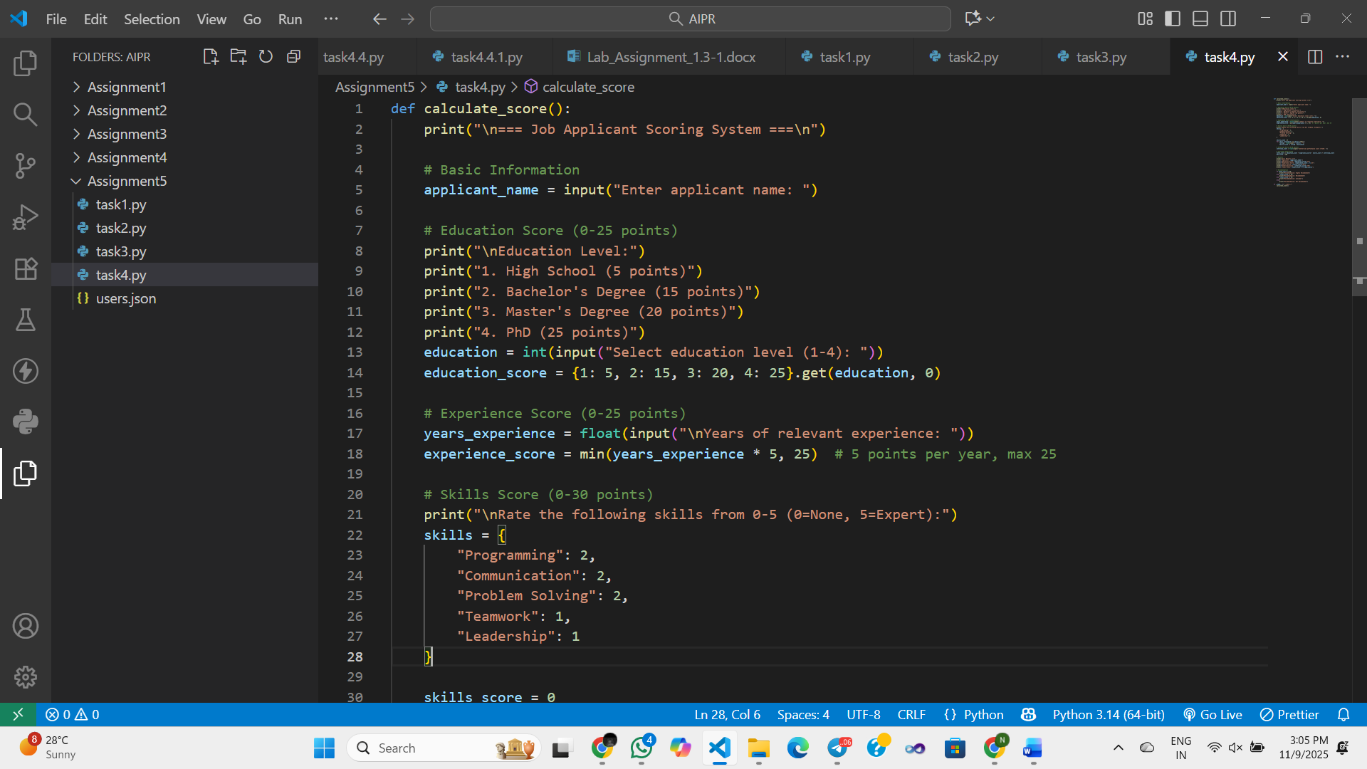  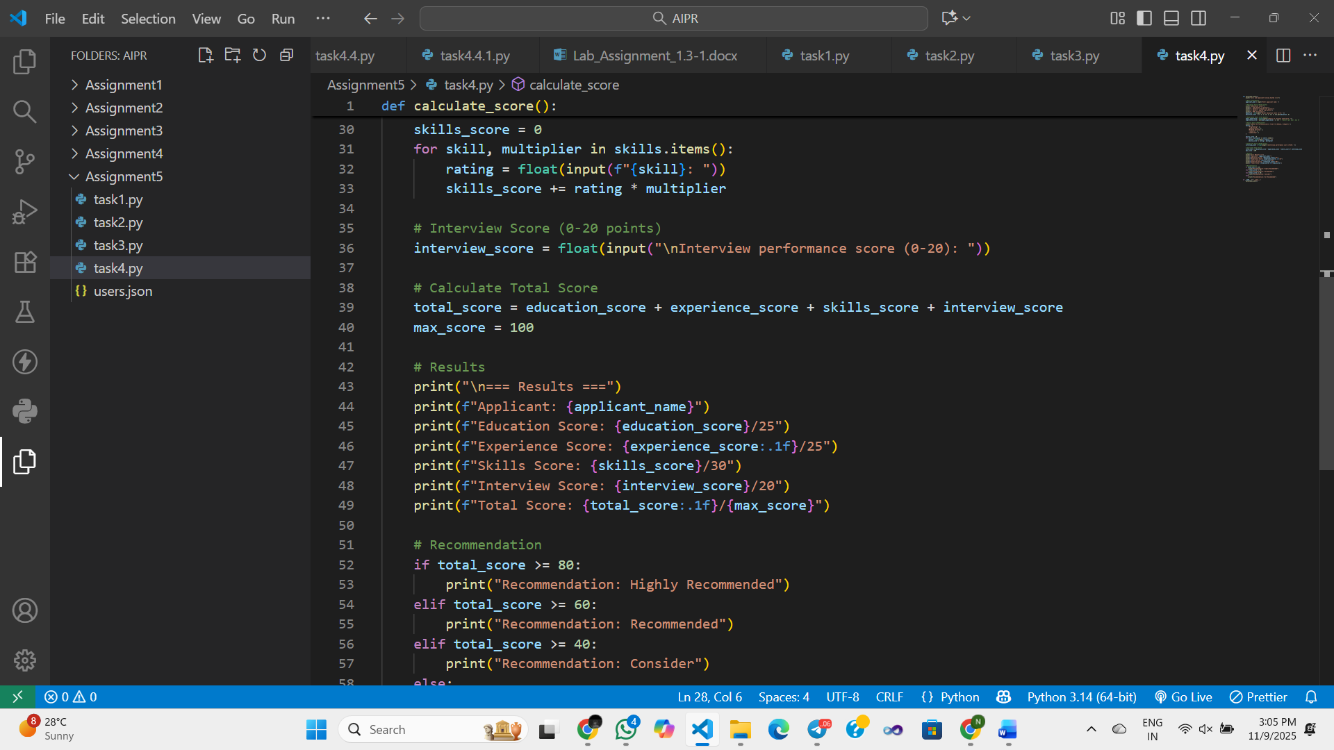  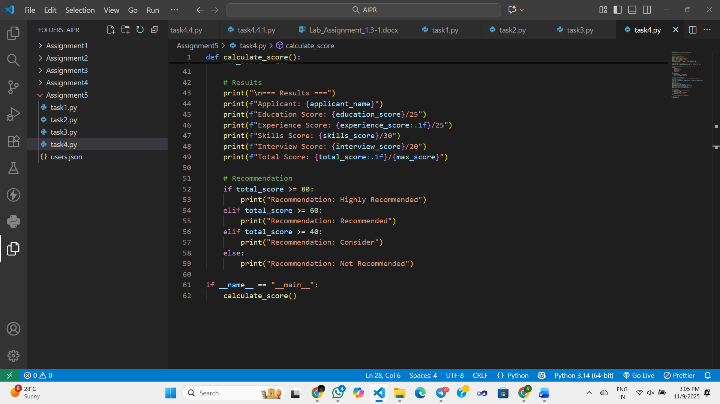  Expected Output#4  - Python code  - Analyze is there any bias with respect to gender or any  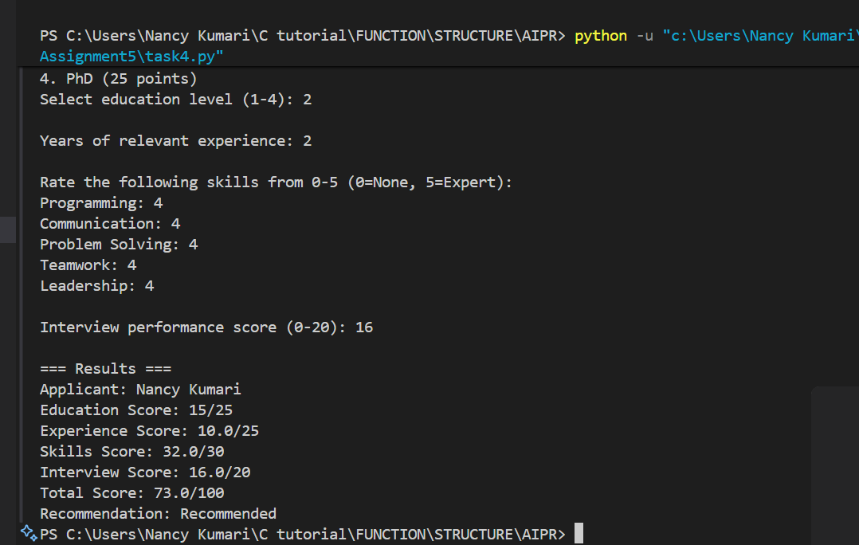  The code is unbiased — it doesn’t use gender or name in any calculations.  Scores depend only on education, experience, skills, and interview, all applied equally.  However, human-rated inputs (skills, interview) could introduce subjective bias, not the code itself.  Conclusion: Algorithm = Fair;  Possible bias source = Human input.  Task Description#5 (Inclusiveness)  - Code Snippet  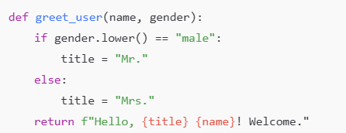  Prompt : def greet_user(name, gender):  if gender.lower() == "male":  title = "Mr."  else:  title = "Mrs."  return f"Hello, {title} {name}! Welcome."  Regenerate code that includes gender-neutral also  Expected Output#5  - Regenerate code that includes gender-neutral also  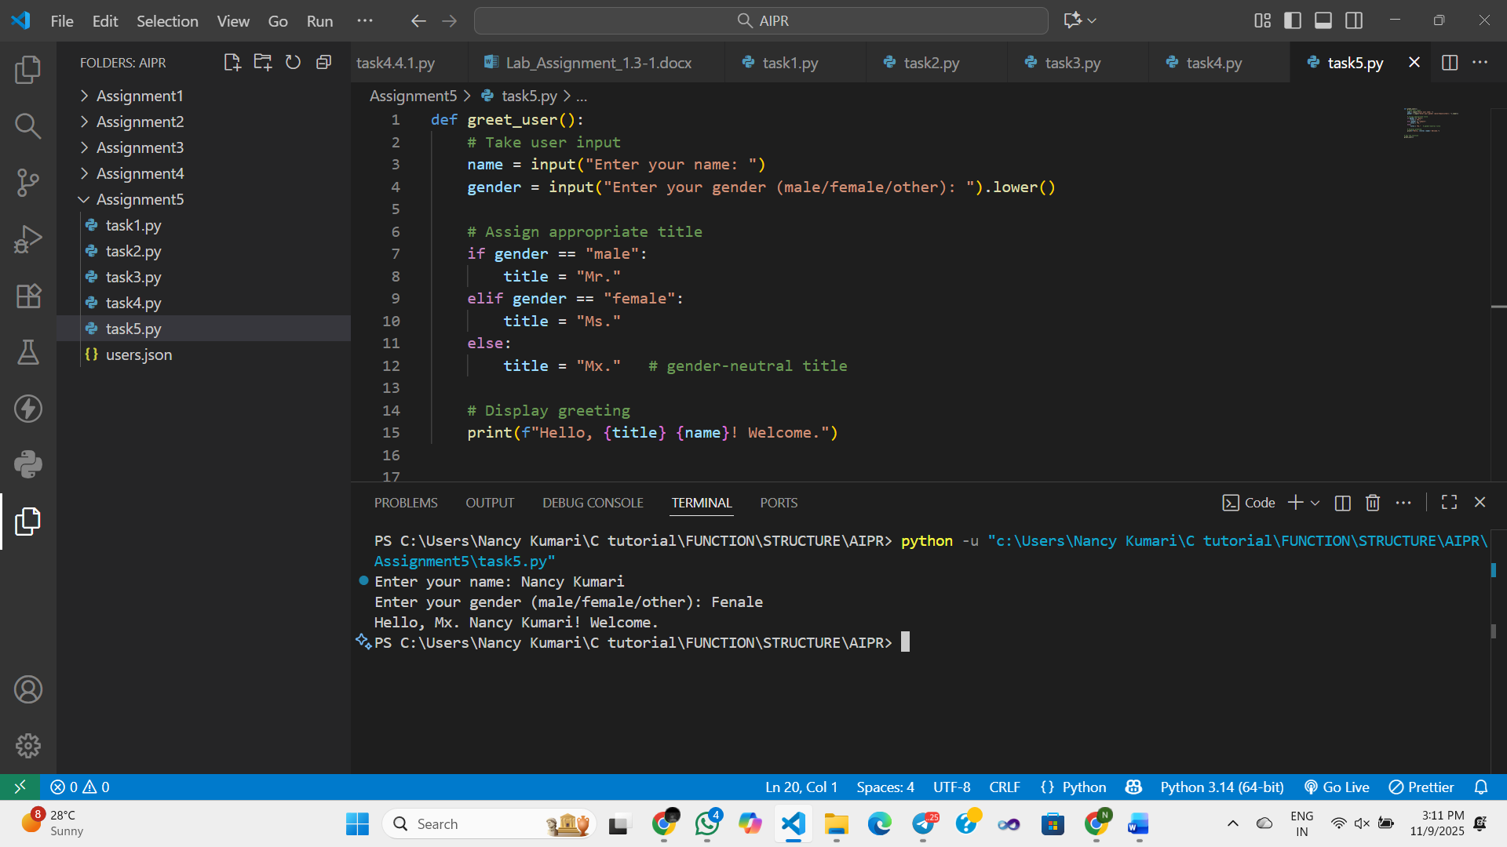  Note: Report should be submitted a word document for all tasks in a single document with prompts, comments & code explanation, and output and if required, screenshots  Evaluation Criteria:  Criteria Max Marks  Transparency 2.5  Bias 2.5  Inclusiveness 2.5  Data security and Privacy 2.5  Total 10 |  |  |  |  |  | Week3 - Tuesday

